Bahria University,

Karachi Campus



LAB EXPERIMENT NO.

**1**

LIST OF TASKS

|  |  |
| --- | --- |
| TASK NO | OBJECTIVE |
| 1 | By using the command line shell interface, practice the commands given in this lab. Write briefly about the usage of each command. |
| 2 | By using gedit, open a text editor and write the C program That print your name. Save the written file as “name.c”. In order to compile and execute the output file, do the following:  $ gcc - o name name.c  $ ./name |
| 3 | Make changes within the above program to display a new output text as given below. Write down the developed program.  Hello World! I am studying Operating Systems.  My name is “Enter your name”.  My registration number is “Enter your registration number”.  I belong to Bahria University Karachi Campus. |
|  |  |
|  |  |
|  |  |

Submitted On:

Date: 07/03/2022

**Task 1: By using the command line shell interface, practice the commands given in this lab. Write briefly about the usage of each command.**

**Solution :**

1. **man Command:**

**man** command in Linux is used to display the user manual of any command that we can run on the terminal.

**Output:**

1. **date Command:**

Use to display date and time.

**Output:**

1. **pwd Command:**

The **pwd** command prints the current working directory path, starting from the root

**Output:**

1. **mkdir Commands:**
2. **mkdir:**

The **mkdir** command in Linux allows users to create or make new directories.

**Output:**

1. **mkdir –p:**

With the help of mkdir -p command you can create sub-directories of a directory. It will create parent directory first, if it doesn't exist. But if it already exists, then it will not print an error message and will move further to create sub-directories.

**Output:**

1. **mkdir –v:**

'mkdir -v' command will print a message that tell info about creation of directory

**Output:**

1. **ls Command:**
2. **ls:**

Used to list information of file:

**Output:**

1. **ls –l:**

 It is used to list information about files and directories within the file system.

**Output:**

1. **ls –a:**

ls -a will list all files including hidden files.

**Output:**

1. **ls –h:**

The ls -h command is used for display content in human readable form.

**Output:**

**Task 2: By using gedit, open a text editor and write the C program That print your name. Save the written file as “name.c”. In order to compile and execute the output file, do the following:**

**$ gcc - o name name.c**

**$ ./name**

**Solution :**

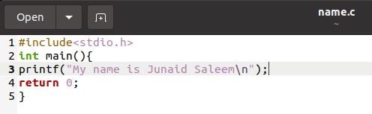

**OUTPUT :**

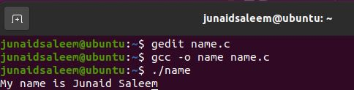

**Task 3 : Make changes within the above program to display a new output text as given below. Write down the developed program.**

**Hello World! I am studying Operating Systems.**

**My name is “Enter your name”.**

**My registration number is “Enter your registration number”.**

**I belong to Bahria University Karachi Campus.**

**Solution :**

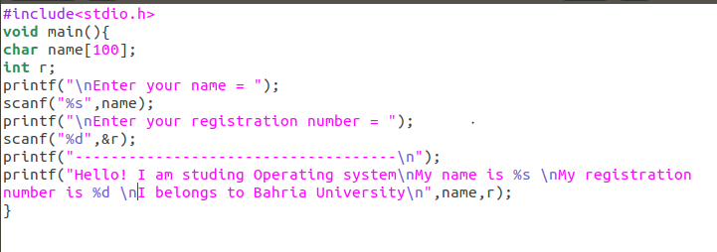

**OUTPUT :**

